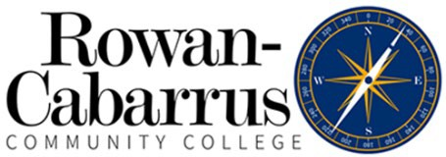

Mission
Advising Syllabus

The Career and Academic Advising (CCA) Center is dedicated to providing students with an advising experience that strengthens the partnership between the student and the college community. Our mission is to promote student success by empowering students to take responsibility for achieving their educational and career goals. We are committed to facilitating this process through collaborative work with students in an environment that is welcoming, professional and supportive.

Advising Goals
The CAA Center Advising Team will:
- Treat students in a friendly, courteous and respectful manner
- Support student decision-making by providing accurate information regarding programs of study, program requirements, transfer options and college policies and procedures
- Teach students to develop and implement educational plans that are compatible with their interests, abilities and lifestyles to promote student success
- Assist students with identifying other college resources that can help them meet their academic and career goals
- Encourage students to become engaged members of the campus and community
- Empower students to make independent and informed career and academic advising decisions

Values
The CAA Center Advising Team uses the following core values as a guide in the development and evaluation of our center’s goals and objectives:
- Mutual Respect
- Accountability
- Responsibility
- Communication
- Collaboration
- Trust

Advisor Responsibilities
- Facilitate students’ exploration of interests, abilities and goals, and help students relate them to programs of study
- Recommend and clarify programs of study based on student interests, abilities and priorities
- Facilitate effective decision-making in students’ selection of program of study
- Assist in the development of an educational plan that satisfies degree requirements
- Recommend appropriate college resources to assist students in reaching their academic goals
- Inform students of and clarify college policies and procedures
- Provide accurate contact information for faculty mentor

Student Responsibilities
- Research program of study thoroughly to ensure that it is compatible with educational and career
- Make contact with appropriate faculty mentor
- Keep a personal record of progress toward degree completion and organize official university documents in a way that is easily accessible for them
- Seek and take advantage of resources that will enhance educational and career goals
- Know the information contained in the Rowan-Cabarrus College Catalog and Student Handbook
- Utilize the guidance and resources provided through the CAA Centers to achieve a level of self-direction and ownership
- Be an advocate for your educational journey

