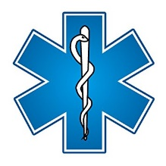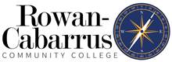

Rowan-Cabarrus Community College
Emergency Medical Services Paramedic Program Information
and Application Packet

Rev. 07/20/22

EMS Career Opportunities

Emergency Medical Service providers may respond to 911 emergency calls, provide critical care transfers, serve in expanded scopes of practice such as community paramedicine, serve on specialty teams, and conduct scheduled patient transfers. Opportunities exist in county, hospital, industrial, and private EMS agencies as well as the fire service. Paramedic level job placement is nearly 100% at present. Statewide EMS job availability and additional career descriptions may be viewed at www.ncems.org.

Course Description:
The curriculum for the Paramedic educational program is the most current release of the United States Department of Transportation (USDOT) National Highway Traffic Safety Administration (NHTSA) National Education Standards. The course prepares students to provide prehospital assessment and care to patients of all ages with a variety of medical conditions and traumatic injuries. Upon successful completion, students are eligible to sit for the NC Paramedic credentialing exam and the National Registry Paramedic exam.
The course complies with standards established by the NC Office of EMS https://info.ncdhhs.gov/dhsr/EMS/pdf/cred/PARAMEDIC-EDUCATIONAL-PROGRAM-REQUIREMENTS.pdf

Program Goal: To prepare and equip candidates with the knowledge, skills, and behaviors necessary to function successfully as competent entry level EMS providers. Additionally, the college strives to deliver a quality education at an affordable cost for basic and advanced level providers. CAAHEP Standard II.C Paramedic: To prepare competent entry- level Paramedics in the cognitive (knowledge), psychomotor (skills), and affective (behavior) learning domains with or without exit points at the Advanced Emergency Medical Technician and/or Emergency Medical Technician, and/or Emergency Medical Responder levels. Advanced Emergency Medical Technician: To prepare competent entry- level Advanced Emergency Medical Technician in the cognitive (knowledge), psychomotor (skills), and affective (behavior) learning domains. Programs adopting educational goals beyond entry-level competence must clearly delineate this intent and provide evidence that all students have achieved the basic competencies prior to entry into the field with or without exit points at the Emergency Medical Technician, and/or Emergency Medical Responder levels. Nothing in this Standard restricts programs from formulating goals beyond entry-level competence.”

Course Objectives
- Describe the roles of Paramedics in the health care system.
- Demonstrate the professional attributes expected of Paramedics.
- Perform the roles and responsibilities of a Paramedic with regard to personal safety and wellness, as well as the safety of others.
- Perform the duties of a Paramedic with regard for medical-legal and ethical issues, including functioning under medical direction and within the scope of practice.
- Apply principles of anatomy, physiology, pathophysiology, life-span development, and therapeutic communications to the assessment and management of patients.
- Identify the need for and perform immediately life-saving interventions to manage a patient’s airway, breathing, and circulation.
- Assess and manage patients of all ages with a variety of complaints, medical conditions and traumatic injuries.
- Apply principles of emergency medical services operations, including considerations in ambulance and air medical transportation, multiple casualty incidents, gaining access to and extricating patients, hazardous materials incidents, and responding to situations involving weapons of mass destruction.

Accreditation:

“The Rowan-Cabarrus Community College Paramedic Program is accredited by the Commission on Accreditation of Allied Health Education Programs (www.caahep.org) upon the recommendation of the Committee on Accreditation of Educational Programs for the Emergency Medical Services Professions (CoAEMSP).”
To contact CAAHEP
Commission on Accreditation of Allied Health Education Programs
25400 U.S. Highway 19 North, Suite 158
Clearwater, FL 33763
www.caahep.org
To contact CoAEMSP
8301 Lakeview Parkway, Suite 111-312
Rowlett TX 75088
(214) 703-8445
FAX (214) 703-8992
www.coaemsp.org
Program outcomes may be viewed at https://www.rccc.edu/emergencyservices/paramedic-program-outcomes/

Programs Offered:
EMS Number | Level | Class Hours | Clinical Hours | Total
EMS 4100 | Emergency Medical Responder | 96 | 0 | 96
EMS 4200 | Emergency Medical Technician | 200 | 48 | 248
EMS 4300 | Advanced Emergency Medical Technician | 160 | 96 | 256
EMS 3163 | EMS Anatomy & Physiology | 100 | 0 | 100
EMS 4400 | Paramedic | 660 | 340-500 | 1000-1160

Prospective students may find additional information about upcoming EMS programs at https://www.rccc.edu/corporatecontinuing/law-fire-emergency-services-training/. Course dates and times vary.

Registration: Prospective paramedic students must meet with the Emergency Medical Services Director for advising prior to enrollment. Students should contact Alan Thompson at alan.thompson@rccc.edu to schedule an advising appointment. Students may register for the EMS credential programs once prerequisites are met. Students must present an approval letter from the Emergency Medical Services Director or designee for registration. Please note the paramedic program is competitive entry and requires additional prerequisites and preregistration. Students may also be scheduled for an entrance examination.

Continuum Profile and Course Affiliation: Prospective students are required to create a profile in Continuum. Information can be found at https://info.ncdhhs.gov/dhsr/EMS/pdf/cred/ContinuumRegistration.pdf. Students are required to affiliate with the EMS educational program in Continuum within 13 days of course start.

Credential Testing: Students successfully completing the EMS credential programs will be eligible for North Carolina EMS credential testing. The NC Office of EMS requires a $68 test fee. National Registry testing is not required; however, students are eligible for testing upon course completion. National Registry information can be found at www.nremt.org. National Registry test fees vary based on location and level.

Prerequisites/Application Packet:
- Age 18 or older
- High school diploma or GED
- NC EMT card (or National Registry)
- Interest letter (why does student wish to become a paramedic)
- Two reference/recommendation letters
- Transcript verification of anatomy & physiology (EMS 3163, BIO 163, BIO 165/166, or BIO 168/169). EMS 3000 is no longer accepted.
- Current CPR card
- Work keys assessment with score of 5 or higher on “workplace documents (reading) assessment” ¹
- Work keys assessment with score of 3 or higher on “applied mathematics concepts”¹
- Completed registration form
- Completed functional job analysis statement
- Completed health/fitness waiver
- Completed code of conduct statement
- Completed photo release
- Shot records documenting all CDC required vaccinations for healthcare providers
- TB skin test or x-ray within the past 12 months that will remain valid for duration of class
- Background check and drug screening²
¹Work keys assessment is exempted with college degree.
²Background and drug screen process will be explained during advising (must use RCCC provider).

General Policies

Tobacco/Alcohol
All classrooms and property of Rowan-Cabarrus Community College are tobacco free; therefore, the use of the following products and variations is prohibited: Cigarettes, E-Cigarettes, Vaping, Smokeless Tobacco, and Chewing Tobacco. Consumption of alcohol at any time while participating in class activities or under the influence of alcohol is prohibited. This includes consuming alcoholic beverages during lunch or while on breaks.

Phones and Computers
Students are expected to refrain from personal use of phones, messaging, social media, and computers during scheduled class time. All devices must be placed in silent mode to prevent classroom disturbances. Students using calculators for tests are NOT permitted to use smart phones for this purpose due to the availability of internet access during testing. Standard calculators only without internet connection are permitted for testing.

Students and Title IX
Sexual Misconduct: Rowan-Cabarrus Community College is committed to providing a safe, respectful and equitable learning environment for all students and employees. Any form of Sexual Misconduct (including sexual harassment, sexual assault, interpersonal violence, and stalking) is considered a form of sexual discrimination and is prohibited by the College under Title IX of the Education Amendments of 1972 and the Violence Against Women Act - Reauthorization 2013. For more information, or to report sexual misconduct or sexual discrimination, please refer to “Title IX –Sexual Misconduct (https://www.rccc.edu/civility/title-ix-sexual-misconduct/ )” on the College’s website.

Student Concerns, Complaints, and Grievances
Rowan-Cabarrus has established specific procedures for specific complaints. For example, formal complaints regarding grades are subject to the Grade Appeal Procedure (https://www.rccc.edu/civility/grade-appealrequest/); complaints regarding discrimination are subject to the Student Grievance policy https://www.rccc.edu/civility/student-grievance/ ). Students will be expected to initiate or express their concern in accordance with those specific guidelines. Generally, students should submit a formal complaint within 30 days after the action that gives rise to the complaint. The College will work with students toward a satisfactory resolution within established policies, procedures and administrative rules. Details about the process, required forms and additional Student Formal Complaints (https://www.rccc.edu/civility/student-complaint/ ) are available on the College's website.
https://www.rccc.edu/civility/

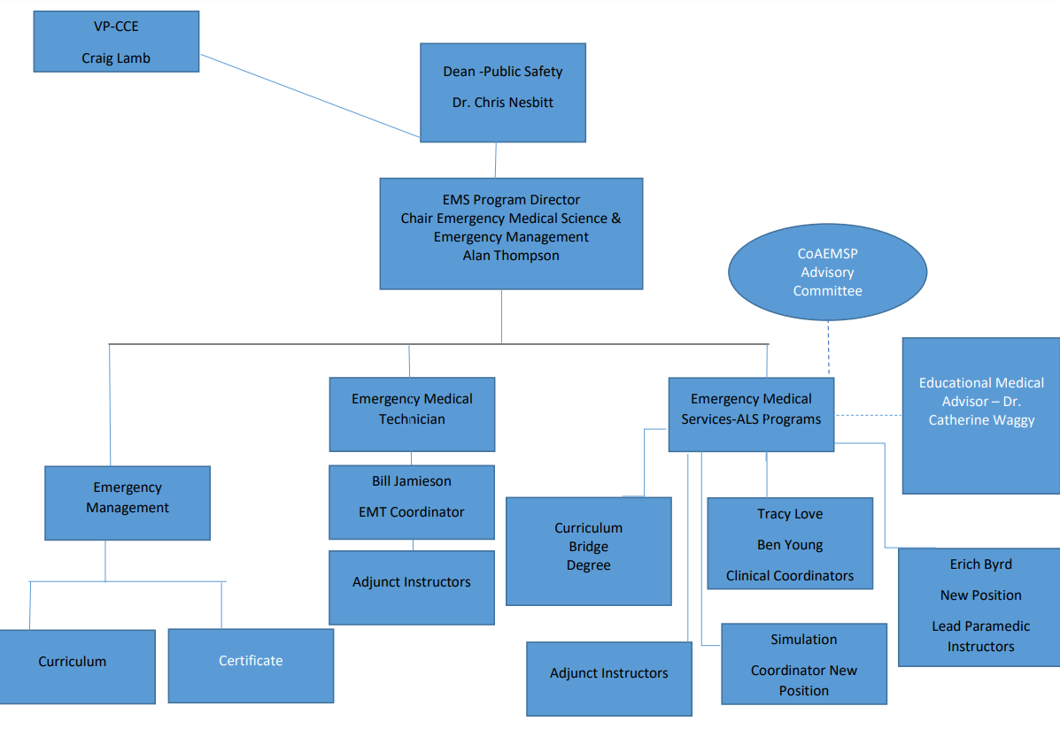

Students with Disabilities
Rowan-Cabarrus Community College abides by Section 504 and Section 508 of the Rehabilitation Act of 1973 and the Americans with Disabilities Act of 1990, which mandate reasonable accommodations be provided to qualified students with disabilities. If a student has a disability and requires instructional and/or testing accommodation, the student should contact the Office of Accessibility (https://www.rccc.edu/accessibility/ ) (OA) at Rowan-Cabarrus prior to the start date of classes or as early as possible into the semester. Students must be registered with the OA in order to receive academic accommodations from faculty; once
registered, written documentation is then provided to the student in order to share with the faculty member(s). The OA at North Campus is located in Building 100 at Student Services, 704-216-3639, and the OA at South Campus is located in Building 1000 at Student Services, 704-216-3613. The NC Office of EMS process for exam accommodation is found at https://info.ncdhhs.gov/dhsr/EMS/faqedu.htm

Non-Discrimination
Rowan-Cabarrus Community College does not discriminate; exclude participation in programs or activities, or limit employment or application opportunities based on race, color, national origin, religion, sex, gender identity or sexual orientation, disability, military or veteran status, or age. Rowan-Cabarrus Community College is an equal opportunity institution and employer. https://www.rccc.edu/civility/non-discrimination-statement/

Confidentiality of Student Records
The Family Educational Rights and Privacy Act of 1974 (FERPA) is a Federal law that governs the maintenance of student records. This act, with which the College intends to comply fully, protects the privacy of educational records, establishes the right for students enrolled to inspect records kept by the College about the student and the right to correct inaccuracies in the records. Rowan-Cabarrus Community College recognizes its responsibilities to students in maintaining accurate and confidential student records. Access to the records by persons other than the student is limited and generally requires prior consent by the student. Rowan-Cabarrus Community College adopted a written policy governing the rights of parents and students under the Family Educational Rights and Privacy Act. Copies of this policy may be found in the Office of the President and the Chief Operating Officer of Student Success & Service Excellence at Rowan-Cabarrus Community College. https://www.rccc.edu/recordsregistration/confidentiality-of-student-records/

Experiential Learning and Transfer Credit
The Rowan-Cabarrus Community College realizes students may have been engaged with other paramedic credential educational opportunities prior to enrollment with our continuing education (non-credit) paramedic program. It is realized students depart educational programs for a variety of reasons. We realize the educational experiences have value to the individual; however, our position is one that greater value is achieved through a cohort based educational experience for continuing education (non-credit) paramedic programs. All components of the paramedic education program at Rowan-Cabarrus Community College must be taken as a cohort. Students will not receive credit for prior learning, experiential learning, or prior coursework for the continuing education (non-credit) paramedic program. Credit for prior clinical and EMS rotations completed in the previous 12 months may be considered after thorough evaluation contingent upon successfully attaining minimum competencies

Teaching-Learning Methods
Teaching-Learning methods for the course may include, but are not limited to, assigned readings, presentations, discussions, critical thinking exercises, labs, projects, clinical, on-line activities, and class activities. A behavioral learning styles assessment may be conducted the first week of class to aid in best practice delivery of material.
Evaluation procedures include quizzes, written examinations, assignments, technical competencies, observation, participation, and technical scope of practice.
The course is designated as hybrid. Information, communications, announcements, assignments, discussions, and tests may be posted on BlackBoard. Students are required to check Blackboard no later than Monday of each week for course related material and communications. Student competencies must be observed in the cognitive, psychomotor, and affective domains.

Remediation
Counseling and coaching may be provided to students with observed deficiencies, performance improvement opportunities, attendance issues, conflict resolution, and students failing to meet required standards. Remedial work may be assigned at the discretion of the lead instructor and/or the Emergency Services Program Director and may include, but is not limited to, research papers, projects, additional clinical, self-study, on-line work, or focused study.

Students not achieving a score of 80% or approved cut score on module tests may retake no more than two module tests over the course of the class in order to achieve the required score of 80% or approved cut score for the purpose of continuing in the course. The average of the first and second attempt will be recorded for grading purposes. The student will be required to complete remedial work assigned by the lead instructor prior to the retest. The retest must be completed within two weeks of the initial test date.

Students not achieving a minimum score of 80% or approved cut score on the final exam will be given one retake attempt after completion of remedial work assigned by the Emergency Medical Services Program team. The retest must be completed within two weeks of the initial test date.

Students not achieving a successful rating on the technical scope of practice testing will be given one retake attempt on the day of testing after consultation with the on-site level II instructor. One additional retest may be given after reviewing the NCCEP Procedures Document and the National Registry Skills sheets. This additional retest must be completed within two weeks of the initial test date.

Those failing to demonstrate the required scores and competencies after remediation will be required to complete the entire initial program.

Course Attendance
Classroom: Student attendance is required at all scheduled didactic and lab sessions. Prompt arrival is expected at all class activities. Absences, tardiness, and leaving early will be counted as hours missed. Students are responsible for missed examinations and material and must complete the activities necessary to make up for the missed work and hours. The instructor may assign additional work. All tests missed due to absences must be taken immediately on the first day of return to the class. Unless extenuating circumstances exist, students missing more than 5% of scheduled didactic and lab hours will be dropped from the course . In all cases, students missing more than 10% of scheduled didactic and lab hours will be dropped from the course. The student must formally make up all missed time.

Clinical/Field: Student attendance is required at all clinical and field internship assignments. Absences, tardiness, and leaving early will be counted as hours missed Absences from clinical and field internship must be discussed in advance with clinical coordinator. All clinical hours must be fully made up through rescheduling with the clinical coordinator. Students missing more than four scheduled clinical or field assignments may be dropped from the course.

Health and Safety
Students must comply with campus health and safety rules https://www.rccc.edu/coronavirus/ . Students should not come to campus if they are sick or have been recently diagnosed with COVID. Hospital clinical providers are currently requiring the COVID vaccine (additional info to follow).

Incident/Injury Reporting and Emergency Plans
Students should notify clinical coordinator and lead instructor as soon as possible for injuries, infectious disease exposures, or incidents occurring in a clinical, field, or classroom setting. The EMS program director may be contacted in the absence of the clinical coordinator or lead instructor. Emergency Plans/Instructions: https://www.rccc.edu/safety/emergency-instructions/

Fitness

The student must be able to perform certain physical activities in order to qualify for successful program completion. Inability to perform these activities at any time within the program may disqualify the student from graduating from the training program and State certification (Paramedic). Paramedic candidates are required to attest compliance with functional job analysis requirements.

Paramedic students may be given the opportunity to participate in non-structured physical activity in the BLET gym and college trails before class and during lunch after completion of a waiver and observing the physical fitness orientation.

Students classified on light duty from employers will NOT be permitted classroom or clinical practice that exceeds light duty restrictions. Students on light duty from employers will not be permitted field clinical rotations during the period of light duty.

Dress Code
Students are expected to maintain a professional appearance at all times in the classroom, clinical rotations, field internships, and when wearing the college uniform in a public area. Professional appearance and bearing are important components of being an EMS provider rather than simply working as an EMS provider. The following requirements constitute the professional appearance and uniform policy for the EMS program at Rowan-Cabarrus Community College:
- Students are required to be cleaned and well-groomed at all times remaining focused on presenting a professional image
- Hair must be kept clean and styled in a manger that will not pose a safety risk.
- Facial hair must be cleaned and well groomed. Facial hair may NOT be permitted to affect the proper seal of protective masks.
- All wounds should be kept clean and bandaged.
- Jewelry: No facial or oral jewelry is permitted that interferes with communications. No ear gauges are permitted during clinical and field rotations. No earrings are permitted that extend below the ear lobe. Rings are not permitted during clinical and field rotations if they have the potential to damage the integrity of protective gloves.
- Tattoos must be covered when working in clinical and field rotations.
- Due to respiratory sensitivities, any fragrance which produces a scent or odor strong enough to be noticed by others including but not limited to, colognes, perfumes, aftershave, and lotions are not to be worn to clinical or field rotations. Also unacceptable are odors from tobacco, alcohol, and those associated with poor hygiene.
- Uniforms:
  - All students are required to wear uniforms during class time, clinical rotations, and field rotations.
  - The uniform consists of a Rowan-Cabarrus Community College Emergency Services Program polo or pullover and black or navy uniform style pants. Students are required to wear a black uniform style belt and solid black uniform style boots/shoes or solid black athletic shoes. Specifically prohibited are open toe shoes, cowboy boots, and non-typical boots/shoes.
  - Socks should be black or navy and extend above the hemline of the pants when seated.
  - Shirts must be tucked in at all times in class, during clinical rotations, during field rotations, and when wearing the uniform shirt in a public area traveling to or from a class associated activity.
  - Students are required to wear a Rowan-Cabarrus Community College nametag.
- The lead instructor, clinical coordinator, or EMS program director may temporarily modify uniform polices for specific situations.
- Students are expected to comply with appropriate dress and uniform policy. Failure to do so will result in warnings. Three appropriate dress or uniform policy violations may result in dismissal from the program.
- Partnering agencies have the right to dismiss a student from clinical or field internships if professional appearance and dress code are not consistent with agency expectations.
- Instructors are required to maintain a “business casual or business” dress code. Alternatively, instructors may wear a Rowan-Cabarrus Community College EMS program uniform.
- Polo shirts and pullovers are available for purchase from Rowan-Cabarrus Community College.
- Students are expected to use appropriate professional discretion in the selection of attire for physical fitness activities.

Course Fees (estimated) ⁴

Item | Cost
Registration (classroom) unless fee exempt fire/EMS/law. | $180
Registration (clinical) unless fee exempt fire/EMS/law | $180
FISDAP registration | $226
Malpractice insurance | $13
Accident insurance | $2.43
Background and drug screen | $53
Text book (primary)⁴ | Paramedic: $400
Specialty certifications/books | $200
Work keys assessment | $20
My Clinical Exchange | $39.50
Supply Fee | $10
Uniform shirts RCCC | $20 each
PPE⁶ | $75
Total Cost | $1418.93

⁴Some educational assistance and scholarships may be available for Paramedic students. NC Fire/EMS/Rescue may be fee exempt. Scholarship information is found at https://www.rccc.edu/r3/ or by contacting 704-216-7201. Additional scholarship information may be found at https://www.rccc.edu/corporatecontinuing/geer-scholarship/ .
⁵Books may be purchased at https://www.rccc.edu/online-bookstore/
⁶Students must provide their own personal protective equipment to include gloves, masks, gowns, and safety glasses (details provided in class).

Course Textbooks and Materials

Jones & Bartlett – Emergency Care in the Streets – 8th Ed – ISBN: 9781284104882
(required)
Jones & Bartlett – Emergency Care in the Streets – Workbook – 8th Ed – ISBN: 978‐1‐284-14225-9 (optional)
Jones & Bartlett – Arrhythmia Recognition – ISBN: 978-0-7637-2246-3 (optional)
Basic Arrhythmias 7th edition (Gail Walraven) – ISBN: 978-0-13-500238-4 (optional)
Pre-Hospital Trauma Life Support – 9th Edition – ISBN: 978-128417-147-1 (required)
Advanced Cardiac Life Support – ISBN: 978-1-61669-772-3 (required)
Pediatric Advanced Life Support – ISBN: 978-1-61669-785-3 (required)
NCOEMS/NCCEP Protocols & Procedures - https://www.ncems.org/nccepstandards.html (required)
NCOEMS Candidate Workbook https://info.ncdhhs.gov/dhsr/EMS/pdf/cred/candidate.pdf
(required)

FISDAP Account Whole Shebang – ordered in class (required)
Additional Recommended Items
In addition to uniforms, books, and general educational supplies students will find the following useful for the class: Standard calculator, EKG calipers, personal stethoscope, safety glasses, watch, and rain suit

General Course Information
- Standard class size 15
- The programs require a great deal of study, reading and application.
- Students are required to maintain an average of 80% and pass exams with an 80%. If FISDAP exams are used then minimum cut score must be achieved.
- Students will receive a student manual regarding additional course policies, requirements, and expectations.
- Professional conduct and appearance are expected to be maintained at highest standards.
- Students are expected to arrive at class on time and attend all classes. Occassional absences and tardiness that are unavoidable may not exceed 5% of class and in extenuating circumstances, 10% of class. All hours missed must be made up through additional course work.
- Students may be dropped from course for absences exceeding 10% of course hours, academic performance not meeting requirements, code of conduct violations, discipline, academic dishonesty, falsification of clinical records, dress code, or other reasons defined by college policy, student manual, or NC Office of EMS.
- The student must be able to perform certain physical activities in order to qualify for successful program completion. Inability to perform these activities at any time within the program may disqualify the student from graduating from the training program and State certification (Paramedic). Paramedic candidates are required to attest compliance with functional job analysis requirements.
- Students may not be dual enrolled in other programs if courses are scheduled to meet on the same day/time.
- Completion of the paramedic program with state certification provides a degree pathway to the Associate in Applied Science degree upon meeting additional bridging course requirements. Degree information can be found at https://www.rccc.edu/beps/emergency-medical-science/
- Military equivalencies may be considered through the NC Office of EMS: https://www.ncems.org/pdf/MilitaryEquivalencyCredentialingProcessOverview-Effective-12-01-2020.pdf

Student Involvement and Evaluation of Instruction and Resources
Students are required to complete institutional evaluations of instruction and CoAEMSP resource evaluations, preceptor evaluations, and instructor evaluations when made available. This is an integral component of the program’s continuous quality improvement process. Students will also be given the opportunity to be involved in committees, outreach events, and other co-curricular activities.

Volunteer Service
Students are required to complete a minimum of eight volunteer service hours during the course of the program. Volunteer service hours may be completed at any 501c3 non-profit, other recognized non-profits by virtue of service, or college outreach events such as career days, STEM events, Skills USA, or others. Volunteer service hour location must be approved by the lead instructor in advance. Documentation of the service hours is required on letterhead from the sponsoring agency.
Culture of Safety and Wholeness
Life happens…even as a public safety provider trying to help others we often discover we too have needs and challenges that must be addressed. The emergency services profession is dangerous and challenging to say the least. Our eyes are often subjected to things we wish we could “un-see.” As a profession and as an educational institution we want each EMS student provider to understand they are not alone. We have listed below local resources available at Rowan-Cabarrus Community College while engaged as a student and a list of phone and internet resources you may find helpful. Never hesitate to contact an instructor or the program director if you need to talk or have unmet needs. We are committed to working with you to promote success and resiliency in your life and chosen profession.

Student wellness center and resources: https://www.rccc.edu/wellness/
Suicide Crisis Lifeline. 988 or 988lifeline.org
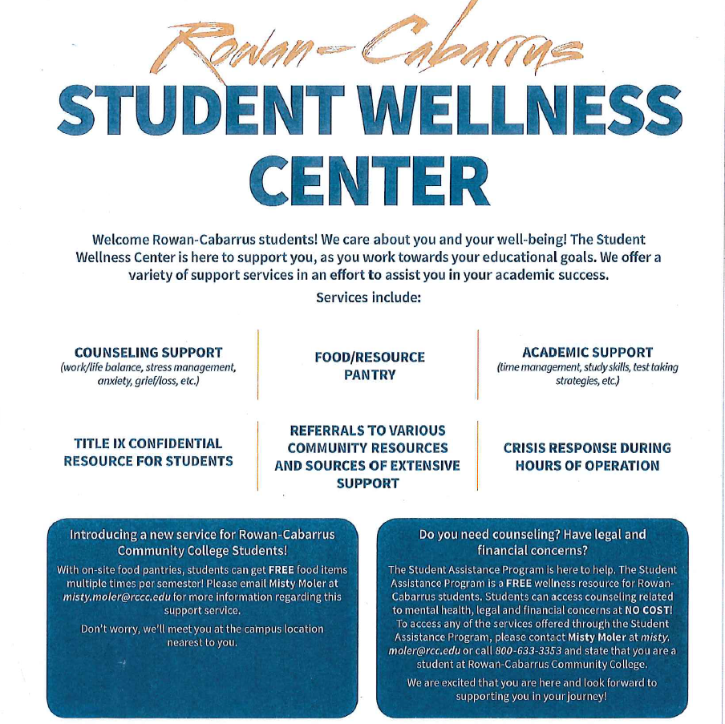
Clinical and Field Hour Requirement Descriptions
Clinical performance, documentation, and technical proficiency will be recorded in FISDAP. Clinical will be completed under the observation of designated clinical preceptors at the following locations
Rowan County EMS Cabarrus County EMS Iredell County EMS
Davie County EMS Stanly County EMS Alamance EMS
Randolph EMS Catawba EMS Lincoln EMS

Atrium Kannapolis Novant Rowan Atrium Harrisburg
Atrium Northeast Novant

*Additional clinical sites may be added as available or deleted…subject to change

Clinical requirements are established and approved by the Medical Director, NC Office of EMS, CoAEMSP, and the CoAEMSP Advisory Committee. Clinical and field rotations must be performed as a student and NOT an employee of the agency performing normal job duties. This restriction does not prohibit employers from paying students for clinical performance. The student must be assigned as a third person to a designated clinical preceptor for field assignments. NC Office of EMS and CoAEMSP special exemptions/exceptions will be considered when activated.

Required Hours
Clinical (Minimum 100; Maximum 200)
- Emergency Department: 48 hours minimum
- Operating Room: 4 hours minimum
- Coronary Care Unit: 8 hours minimum
- Intensive Care Unit: 8 hours minimum
- Obstetrics: 8 hours minimum
- Pediatrics: 8 hours minimum
- Psychiatric: 4 hours minimum
- Neurology: 8 hours minimum
- Cardiac catheterization lab when available
Field Internship (Minimum 240; Maximum 300)
- Required: EMS agencies
- Optional: Special operations/events

The following basic competencies must be evaluated and documented prior to any live patient encounters in clinical, field experience, or capstone field internship:

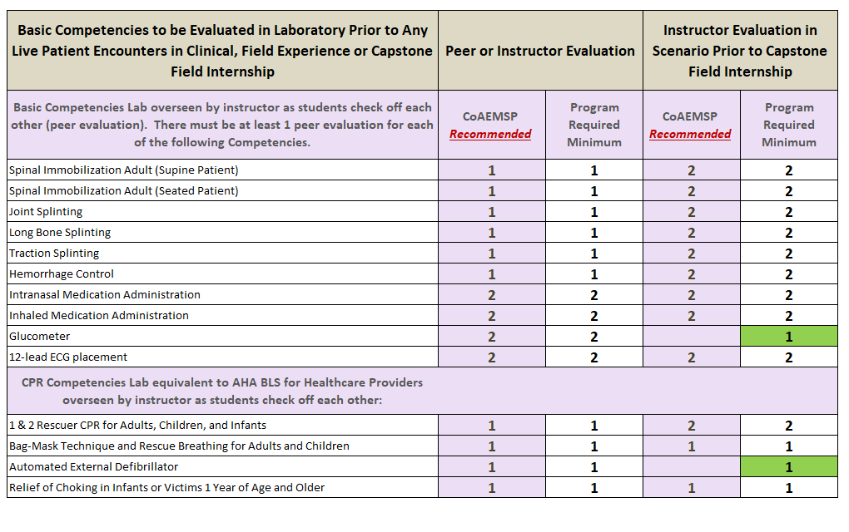

Functional Job Analysis (Paramedic)
Must be at least 18 years of age and be a high school graduate or equivalent. Must have proof of valid driver’s license. Ability to communicate verbally; via telephone and radio equipment; ability to lift, carry, and balance up to 125 pounds (250 with assistance); ability to interpret and respond to written, oral, and diagnostic form instructions; ability to use good judgment and remain calm in high-stress situations and take on role of a leader.
Must have the ability to read road maps; drive vehicle, accurately discern street signs and address numbers, read medication/prescription labels and directions for usage in quick, accurate, and expedient manner, ability to communicate verbally with patients and significant others in diverse cultural and age groups to interview patient, family members, and bystanders, and ability to discern deviations/changes in eye/skin coloration due to patient=s condition and to the treatment given. Must be able to document, in writing, all relevant information in prescribed format in light of legal ramifications of such; ability to converse with dispatcher and EMS providers via phone or radio as to status of patient.
Good manual dexterity with ability to perform all tasks related to advanced emergency patient care and documentation. Ability to bend, stoop, balance, and crawl on uneven terrain; and the ability to withstand varied environmental conditions such as extreme heat, cold, and moisture. Ability to perform quickly, precise, practical mathematical calculations pertinent to ratio and proportion of medication and supplies used in emergency patient care. Must be independent, confident, able to work independently without defined structure, have good stable reasoning ability with ability to draw valid conclusions expediently relevant to patient’s condition, often, using limited information. Must have knowledge and skills relevant to position and be able to implement them in stressful situations. Must be cognizant of all legal, ethical, and moral obligations inherent within scope of practice.
Must be able to perform mathematical calculations/ratios and apply them in expedient, practical manner. Must be independent, confident, able to work independently without structure, have good stable reasoning ability and able to draw valid conclusions quickly relevant to patient’s condition, often, using limited information. Must have knowledge and skills relevant to position and be able to implement them in practical fashion in stressful situations. Must be cognizant of all legal, ethical, and moral obligations inherent within scope of practice.
My signature below attests my understanding of the essential functions of paramedic and compliance or ability to comply with the requirements of the functional job analysis with successful course completion.
_______________________________________ _____________________________________
Signature Print
_____________________
Date

HEALTH & FITNESS WAIVER/INFORMED CONSENT FORM

I, ________________________________, have enrolled in the exercise program offered at Rowan-Cabarrus Community College (RCCC). I recognize that the program may involve strenuous physical activity and other various fitness activities. I hereby affirm that I am in good physical condition and do not suffer from any known disability or condition which would prevent or limit my participation in this exercise program. I acknowledge that my enrollment and subsequent participation is purely voluntary and in no way mandated by RCCC.

In consideration of my participation in this program, I hereby release the instructor, RCCC and its agents from any claims, demands and causes of action as a result of my voluntary participation and enrollment including workers compensation claims.

I fully understand that I may injure myself as a result of my enrollment and subsequent participation in this program and I hereby release the instructor, RCCC and its agents from any liability now or in the future for conditions that I may obtain. These conditions may include, but are not limited to, heart attacks, muscle strains, muscle pulls, muscle tears, broken bones, shin splints, heat prostration, injuries to knees, injuries to back, injuries to foot, or any other illness or soreness related to or caused by my participation, including death.

I HEREBY AFFIRM THAT I HAVE READ AND FULLY UNDERSTAND THE ABOVE STATEMENTS.

_______________________________________
Participant Signature

________________________________________
Printed Participant Name

________________________________________
Date

________________________________________
Email

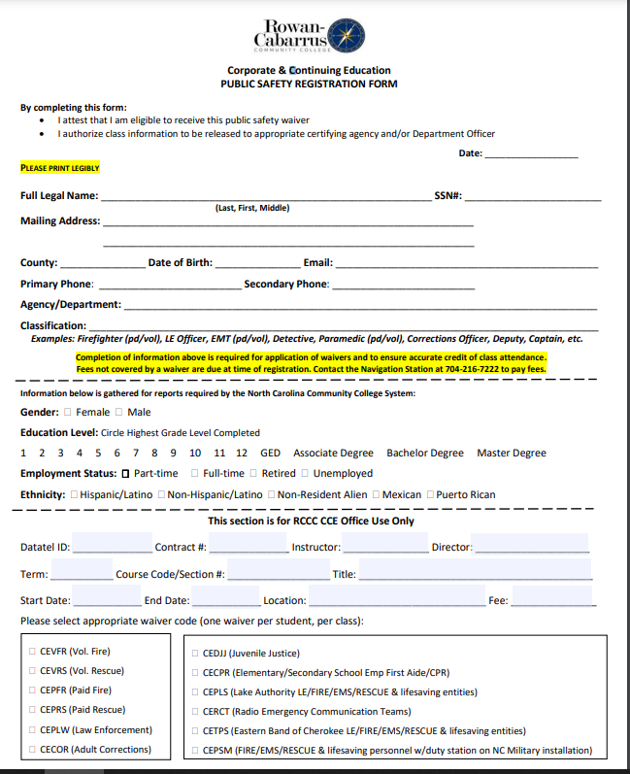

Emergency Medical Service Program Immunization Requirements

Immunizations
Students are required to provide evidence of and attest to the compliance with Center for Disease Control (CDC) Healthcare provider required vaccinations prior to being permitted clinical or field practice. Students are required to comply with clinical and field provider immunization and infection control practices.
Emergency Medical Service Program Immunization Requirements

- Hepatitis B Vaccine series (must have completed a minimum of first two)
Vaccine 1: ________ Vaccine 2: ________ Vaccine 3: ________
- MMR Vaccine series or evidence of positive titer.
Vaccine 1: ________ Vaccine 2: ________ Titer: ________
- Varicella Vaccine or evidence of positive titer.
Vaccine: ________ Titer: ________
- DPT Vaccine or Tdap or Pd.
Vaccine: ________
- Tetanus Immunization (must be within 10 years)
Vaccine: ________
- Influenza seasonal vaccine. (Must remain current during declared flu season)
Vaccine: ________
- COVID vaccine.
Vaccine: ________
- Tuberculosis testing (must remain current within 1 year of testing during clinical performance). Students performing clinical at Rowan Regional are required to have two TB test annually.
TB 1: ________ TB 2: ________
Student Signature: ______________________________________ Date: _______________
Student Name: _________________________________________
Healthcare Provider Signature: ____________________________ Date: ________________
Healthcare Provider Name: _______________________________________

Background Check and Drug Screening

- Background checks and drug screening will be conducted by Background Investigation Bureau (BIB) for the purpose of determining program and clinical eligibility.

- The background check will consist of address history trace, court record search, criminal record database search, sex offender registry review, Homeland Security watch list review, and alias identification. The drug screen will consist of a non-DOT 10 panel urine drug screen.

- Students are directly responsible for the fees to conduct the testing. Current pricing for drug screen and background check is $53 (subject to change)

- Paramedic students should contact tracy.love@rccc.edu for authorization code and access for drug screening.

- Students are encouraged to review 10A NCAC 13P .0502, .0511, .1502, and .1507 regarding credentialing requirements and criminal records at http://reports.oah.state.nc.us/ncac/title%2010a%20-%20health%20and%20human%20services/chapter%2013%20-%20nc%20medical%20care%20commission/subchapter%20p/subchapter%20p%20rules.pdf

- Criminal records pre-determination process https://www.ncems.org/pdf/OEMS-CRC-Requirements-HB-770-and-Predetermination-Process-Overview.pdf

Code of Ethics for EMS Practitioners
Professional status as an Emergency Medical Services (EMS) Practitioner is maintained and enriched by the willingness of the individual practitioner to accept and fulfill obligations to society, other medical professionals, and the EMS profession. As an EMS practitioner, I solemnly pledge myself to the following code of professional ethics:
- To conserve life, alleviate suffering, promote health, do no harm, and encourage the quality and equal availability of emergency medical care.
- To provide services based on human need, with compassion and respect for human dignity, unrestricted by consideration of nationality, race, creed, color, or status; to not judge the merits of the patient’s request for service, nor allow the patient’s socioeconomic status to influence our demeanor or the care that we provide.
- To not use professional knowledge and skills in any enterprise detrimental to the public wellbeing.
- To respect and hold in confidence all information of a confidential nature obtained in the course of professional service unless required by law to divulge such information.
- To use social media in a responsible and professional manner that does not discredit, dishonor, or embarrass an EMS organization, co-workers, other health care practitioners, patients, individuals or the community at large.
- To maintain professional competence, striving always for clinical excellence in the delivery of patient care.
- To assume responsibility in upholding standards of professional practice and education.
- To assume responsibility for individual professional actions and judgment, both in dependent and independent emergency functions, and to know and uphold the laws which affect the practice of EMS.
- To be aware of and participate in matters of legislation and regulation affecting EMS.
- To work cooperatively with EMS associates and other allied healthcare professionals in the best interest of our patients.
- To refuse participation in unethical procedures and assume the responsibility to expose incompetence or unethical conduct of others to the appropriate authority in a proper and professional manner.
________________________________________
Originally written by: Charles B.Gillespie, M.D., and adopted by the National Association of Emergency Medical Technicians, 1978. Revised and adopted by the National Association of Emergency Medical Technicians, June 14, 2013.
Student Code of Conduct

Students Shall:
- Abide by all rules, regulations, policies, and procedures governing the college.
- Abide by RCCC Code of Conduct policy and program specific guidelines
- Demonstrate common courtesy and respect for faculty members, administrative staff, other students and guests of the college.
- Attend all class meetings unless excused by the instructor.
- Arrive at class on time and prepared for the day’s lecture.
- Demonstrate highest levels of professionalism through conduct and appearance.

Students Shall Not:
- Possess, consume, distribute or be under the influence of alcoholic beverages or illegal drugs.
- Use, possess or transport any weapons.
- Behave in a loud or boisterous manner so as to interrupt or interfere with ongoing classes and/or the academic learning environment.
- Damage, destroy or attempt to damage or destroy the property of the college or the property of someone else.
- Endanger or threaten to endanger the personal safety of anyone. Intentionally causing or attempting to cause injury or causing emotional stress is included within the meaning of this provision.
- Behave in an offensive manner toward anyone, to include the public use of vulgar, profane and/or obscene language. Dress inappropriate, offensive or unprofessional manner.
- Steal or borrow without permission the possessions(s) of anyone.
- Lie to anyone concerning college related matters.
- Forge, alter or otherwise misuse any college document or record.
- Cheat on an examination, homework, or other assignment, collaborate without permission in work to be presented in class, plagiarize, or knowingly assist another student in any of the above prohibited activities.
- Behave in an insubordinate manner inappropriate for the academic environment, to include student disrespect and contempt for college officials. This prohibition includes failure to comply with the reasonable requests of teachers in pursuit of class learning objectives and the maintenance of good order and discipline.
- Students may not bring their children to class or leave their children unattended while on campus.
- Students shall not disobey COVID and other infectious disease guidelines for classroom, on campus, and clinical activities.
- Students shall not use tobacco products (to include smoking, smokeless tobacco, or vaping) on campus.

Academic Integrity and Professionalism
Students are expected to conduct themselves in accordance with the professional expectations of the profession and the college at all times. Students are reminded they are representatives of Rowan-Cabarrus Community College whenever and wherever they are involved with course related activities and when wearing the Rowan-Cabarrus Community College uniform. Professional conduct is essential to a successful course experience and EMS career.
Academic dishonesty and/or serious code of conduct violations may result in immediate dismissal from the program. Falsification of clinical records may result in immediate dismissal from program. Students banned or dismissed from clinical or field internship sites will not be permitted to complete the clinical and field component of the course. Students placed under investigation by the NC Office of EMS for rule, conduct, or criminal record investigation may be suspended from clinical and field internship sites pending disposition of investigation.
The college prohibits taking or acquiring possession of any academic material (test information, research papers, notes, etc.) from a member of the college staff or another student without permission; receiving or giving help during tests; submitting papers or reports presented as the student’s original work that are not entirely the student’s own; and not giving credit for other’s work.
All students are expected to be familiar with and abide by the policies, procedures, and standards of Rowan-Cabarrus Community College to include, but not limited to, the Campus Code of Conduct and Student Internet Acceptable Use. https://www.rccc.edu/civility/code-of-conduct/

Certification
I have read and thoroughly understand the above student conduct expectations and prohibitions and will abide by them at all times while a student at Rowan-Cabarrus Community College. Also, I thoroughly understand that failure to comply with the above expectations and prohibitions may result in disciplinary action against me by RCCC to include suspension from class or expulsion from the college.
Student Signature: ____________________________________ Date: ____________________
Student Name (Printed): _________________________________________
Witness: ____________________________________________ Date: ____________________

Placement Testing Advanced EMS Educational Programs (Advanced EMT-AEMT and Paramedic)

Paramedic and Advanced EMT students are required to have placement testing demonstrating post-secondary education level in reading and math.
Students who have been awarded a college degree (associates, associates in applied science, bachelors, masters, etc.) or who have transcripts verifying college level math and English are exempt. Please provide a copy to the EMS program director Alan Thompson at alan.thompson@rccc.edu or Rowan-Cabarrus Community College, Attn: Alan Thompson Building 400, PO Box 1595, Salisbury, NC 28145.
The program we use at Rowan-Cabarrus Community College is the work keys program. Students are required to complete the work keys with the following levels:
- Work keys assessment with a score of 5 or higher on work place documents (reading) assessment)
- Work keys assessment with a score of 3 or higher on applied mathematics concepts.

Work keys information is found at:
https://www.rccc.edu/workforce/workkeys-testing/
Students are invited to schedule a conversation or pre-test with the employability lab. You may contact them at 704/216-7201, r3@rccc.edu, or cassandra.barrier@rccc.edu
Work keys scheduling may be completed at: testingcenter@rccc.edu or https://booknow.appointment-plus.com/16e9j75k/

Use the email if appointments are not available.

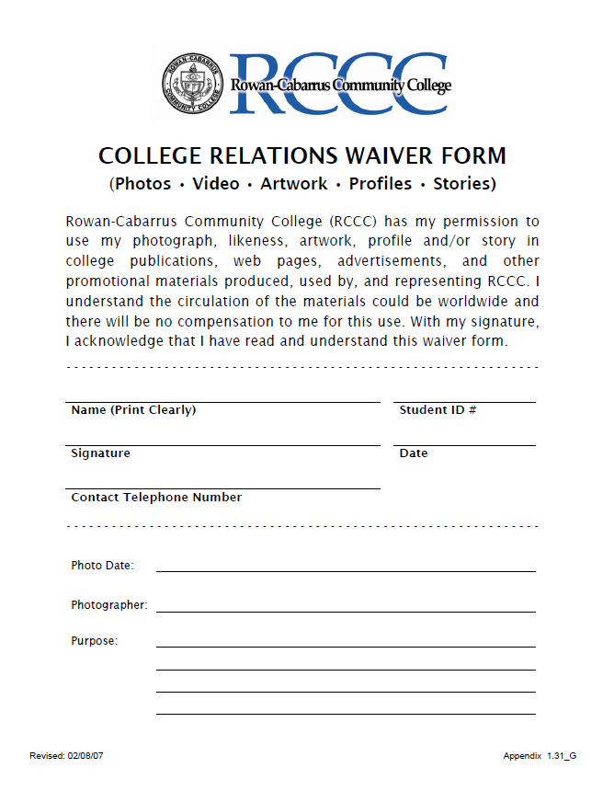

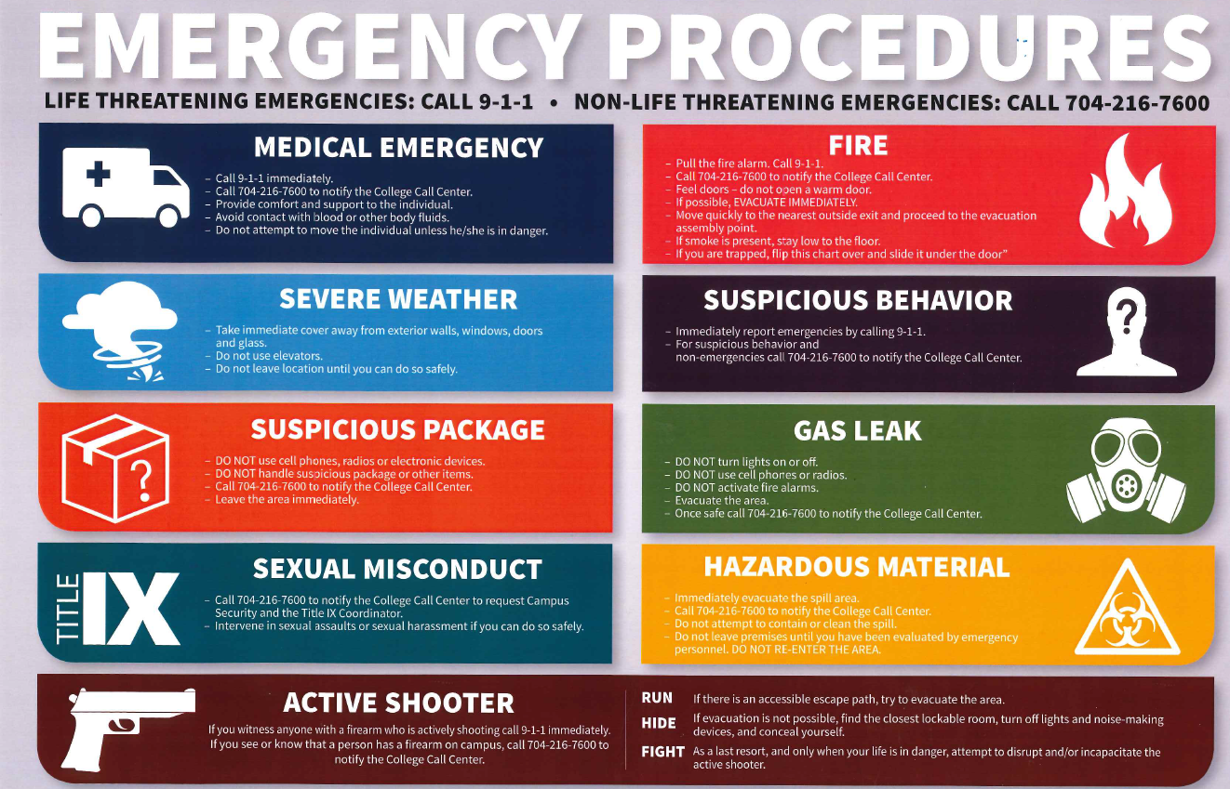

PARAMEDIC PROGRAM RELEASE OF CONFIDENTIAL INFORMATION

The purpose of this release is to provide verified representatives of your sponsoring emergency service agencies access while conducting specific inquiries related to your paramedic program academic performance.

The Family Educational Rights and Privacy Act (FERPA) seeks to guarantee both a student’s right of access to education records and the confidentiality of student information. Institutions may not disclose information contained in education records without the student’s written consent except under certain conditions. A student’s record may be released to parents, guardians, or other third parties by providing written authorization or consent
https://www.rccc.edu/recordsregistration/wp-content/uploads/sites/7/2018/06/FERPA-form.pdf FERPA deals only with student related “Educational Records.” FERPA regulations state the education records are (1) directly related (“personally identifiable”) to a student and (2) maintained by the institution.

As a student in the paramedic education program at Rowan-Cabarrus Community College, I hereby authorize the paramedic program director, or designee to release any information pertaining to my test scores (written and practical), class schedule, attendance, academic record (transcript, grades, GPA and academic standing) and disciplinary information to verified representatives of my sponsoring EMS agency. This release is effective from the first day of class through the last day of didactic and/or field internship components. A student has the right to rescind this release at any time, subject to information previously disclosed under this release, by providing a written request to the paramedic program director.
I authorize release of information in accordance with directions above to _____________________ EMS agency located in ___________________during the period of my paramedic program.

________________________________________ ____________________ _________________
Student Name Student ID Phone Number

This form is only for the release of records authorized by the student indicated on the form. This form will be forwarded to the Registrar’s Office. An additional copy will be kept in your paramedic program file.

I understand the information disclosed is protected under the confidentiality legislation and cannot be disclosed without my written consent unless otherwise provided for in the regulations

Signature of Student Date

________________________________________ _________________________
Signature of Witness Date

Paramedic Student File Checklist of Required Documents - RCCC
Student Name____________________________________________________________
Contract Number/Datatel: _______________________________________________
NC OEMS course Number___________________________________________________
Lead Instructor____________________________________________________________
Course Begin/End Dates____________________________________________________
Student Final Course Grade (Numeric and Alpha)________________________________
Pre-Requisites:
- High School Diploma or High School Equivalency (or college transcript)
- Reading Comprehension and English Language Assessment or Educational Equivalent at Post-Secondary Level (scores or college transcript)
- Math Assessment or Educational Equivalent at Post-Secondary Level (scores or college transcript)
- Documentation of Successful Completion of EMT Educational Program (certificate or credential)
- Documentation of Successful Completion of Anatomy & Physiology (Pre/Co-requisite) (transcript or certificate)
Other
- CPR card
- Interest Letter
- Two reference letters
- Statement of physical ability (functional job analysis statement
- Background/drug screening verification
- Code of Conduct statement
- Course information packet verification of receipt
- Course registration form
- Verification of vaccinations
Course Documents:
- Written test/quizzes answer sheets and/or tests
- Completed independent skills evaluation check sheets (200 hours lab)
- Completed TSOP check sheets
- Recommendation of Medical Advisor/Director and Lead Instructor to participate in Clinical/Field Internship
- Documentation of Field Internship and Skills Completion/Competency
- Documentation of Clinical Time and Skills Completion/Competency
- Verification of Medical Advisor/Director and Lead Instructor of successful completion of course and all competencies

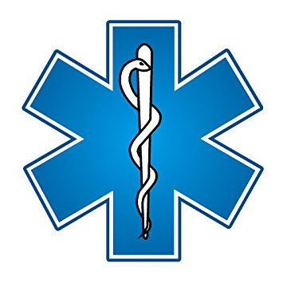
Paramedic Program Application Packet Checklist

Student Name: _________________________________

Student ID Number if known (RCCC): ________________________________

Advising Date: _________________________________

Student Preferred Email: _________________________________

Student Phone: __________________________________

NCOEMS P# or NREMT#: ___________________________________

Preferred Course: ___________________________________

Current EMS/Fire/Rescue Agency: ___________________________________

College Degree: ___________________________________

Item | Initial for compliance | Comments
Age 18 or older
High School Diploma / GED |  | Attach copy of HS, GED, or college degree
NC EMT or NREMT |  | Attach copy
Interest letter |  | Attach copy
Two reference letters |  | Attach copies
A&P Transcript  (EMS 3163, BIO 163, BIO 165/166, or BIO 168/169) |  | Attach transcript or certificate
CPR card |  | Attach copy
Work keys assessment with score of 5 or higher on “workplace documents (reading) assessment” * |  | Attach results or copy of college degree
Work keys assessment with score of 3 or higher on “applied mathematics concepts” * |  | Attach results or copy of college degree
Course registration |  | Attach copy
Functional job analysis attestation |  | Attach Signed Copy
Health/Fitness release |  | Attach Signed Copy
Student Code of Conduct Statement |  | Attached Signed Copy
Photo release |  | Attach signed copy
Vaccination and TB test |  | Attached Physician record or copy from packet signed by physician
Reviewed AAS Bridge and AAS for EMS |  | Will be reviewed during advising
Background check and drug screen results |  | Will be reviewed during advising
COVID mitigation |  | Will be reviewed during advising

______________________________________________________ ______________________
Student signature & print date

Contact Information:

EMS Program Director – Emergency Medical Science Chair:
Alan Thompson, BS, NRP, Paramedic
Level II Instructor/Coordinator
Alan.thompson@rccc.edu 704/216-7141

